MONTHLY TEST – JUNE 2019
Marks obtained:

Total:25
Name: _____________
Grade: II Section ___
Subject: EVS
Date: 28.06.19
Time: 1 Hour

I. Choose the correct answer. (5x1=5)
1. ___________help us see things.
a) eyes b) tongue c)teeth

2. Which set of body parts are found in the head?
a) hands, fingers, wrist
b) hair, shoulder, stomach
c) mouth, eyes, ears
3. We ride bicycle with our _____________
a) hands and legs b) nose and legs c) legs and ears
4.___________ joins the head and the rest of the body
a) mouth b) neck c) teeth

5. You can listen to music with …….
a) mouth b) ears c) eyes

II. Fill in the blanks with ‘can’ or ‘cannot’. (5x1=5)
1. A dog __________ fly, but it _____________ smell very well.
2. A fish ___________ swim, but it ______________ talk.
3. A cat ________________ fly, but ___________catch a mouse.
4. A parrot __________ mimic words, but it __________ swim in the sea.
5. A monkey ______________ speak, but it __________ climb trees.

III. Sequence the picture in order from 1 to 4. (4x1=4)
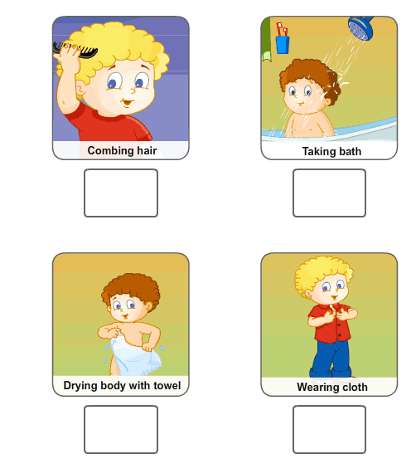
IV. Write any two talents you have. (1x2=2)
1. _________________________
2. _________________________

V. Identify the parts of the body with the help of given box. (6x1=6)

head | Toe | neck
arm | Nose | leg

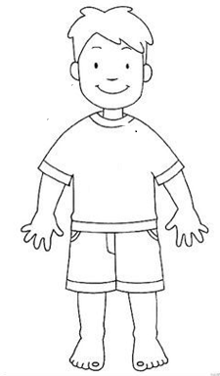
VI. Match the weather with their related items. (3x1=3)

